

Responsive Theme

Functional Design Document

Document History

|  |  |  |  |
| --- | --- | --- | --- |
| **Version** | **Updated by** | **Date** | **Comments** |
| 1.0 | Shashank Bezalwar | 04/03/2015 | DRAFT |
| 2.0 | Shashank Bezalwar | 06/04/2015 | Modified for the updated template |
|  |  |  |  |
|  |  |  |  |
|  |  |  |  |
|  |  |  |  |
|  |  |  |  |

Document Sign-off

|  |  |  |  |
| --- | --- | --- | --- |
| **Name** | **Role** | **Date** | **Signature** |
| **Pascal ESPINOUSE** |  |  |  |
| **Aliasgar Muchhala** |  |  |  |
| **Gyaneshwar Dubey** |  |  |  |
|  |  |  |  |
|  |  |  |  |
|  |  |  |  |
|  |  |  |  |

Document references

|  |  |  |  |
| --- | --- | --- | --- |
| **Reference and Document Title** | | **Version Number** | **Date** |
|  |  |  |  |

# Table of Contents

Table of Contents 2

1. Introduction 4

1.1 Document Purpose 4

1.2 Intended Audience 4

1.3 Document Scope 4

1.4 Document Structure 4

1.5 Additional Resources 4

2. Brief description of the responsive theme 5

2.1 Responsive Theme description 5

2.2 Use Case 5

2.3 Functional Detail 5

2.4 Responsive Theme 5

2.4.1 Display Rule 5

2.4.2 Business Rule Description 6

2.5 Exception Management and Logging 8

2.5.1 Exception Management 8

2.5.2 Logging / Audit 8

2.6 Security requirements 8

1. Introduction
   1. Document Purpose

This document is the Functional Design Document which provides information of Responsive Theme. It covers:   
a) Brief description of the Responsive Theme.

* 1. Intended Audience

This document is aimed at the client who wants to discover the principle of the Responsive Theme in Hybris.

* 1. Document Scope

This document covers the details about the Responsive Theme implemented in Hybris.

* 1. Document Structure

|  |  |  |
| --- | --- | --- |
| Section | | Description |
| 1 | Introduction | Describes the purpose and intended audience of the document and explains its structure. |
| 2 | Brief Description | Overview of the module. |
| 3 | Appendices | Supporting information |

* 1. Additional Resources

|  |  |  |  |
| --- | --- | --- | --- |
| # | Description | URL | Purpose |
| 1 | Wiki Portal | <https://wiki.hybris.com> | To gather more information |
| 2 | Coconet | https://coconet2.capgemini.com/sf/go/doc3318908?nav=1 | To refer technical specifications |

1. Brief description of the responsive theme
   1. Responsive Theme description

The responsive theme is created to provide an optimal viewing experience, easy reading and navigation on mobile phones, tablets, laptop and desktop computers. The responsive theme's layout adjusts to the device's screen size. This enables to maintain only one site and no need for a separate mobile site or mobile plug-in, the content will be resized and rearranged to fit smaller screens.

* 1. Use Case
  2. 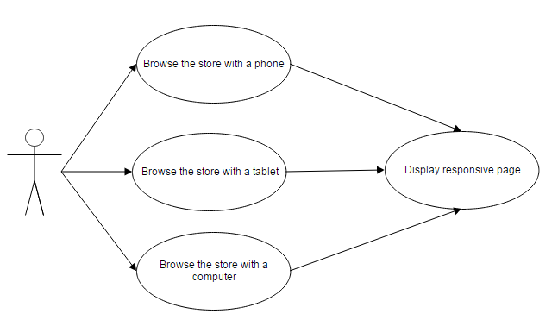Functional Detail

Responsive Theme provides an optimal viewing experience, easy reading and navigation with a minimum of resizing, panning, and scrolling—across a wide range of devices (from desktop computer monitors to mobile phones).

Responsive Theme adapts the layout to the viewing environment by using fluid, proportion-based grids, flexible images, and CSS3 media queries, an extension of the @media rule, in the following ways:

* The fluid grid concept calls for page element sizing to be in relative units like percentages, rather than absolute units like pixels or points.
* Flexible images are also sized in relative units, so as to prevent them from displaying outside their containing element.
* Media queries allow the page to use different CSS style rules based on characteristics of the device the site is being displayed on, most commonly the width of the browser.
  1. Responsive Theme
     1. Display Rule

Below is the Display rule for the various devices.

## Desktop range

The Powertools store within the desktop range does not require hiding or collapsing of any page elements.

For example, on the home page:

* The store header contains all information, such as available category selections.
* The centre image is fully visible and centered.
* The images in the storefront display at a large size.

## Desktop screen capture

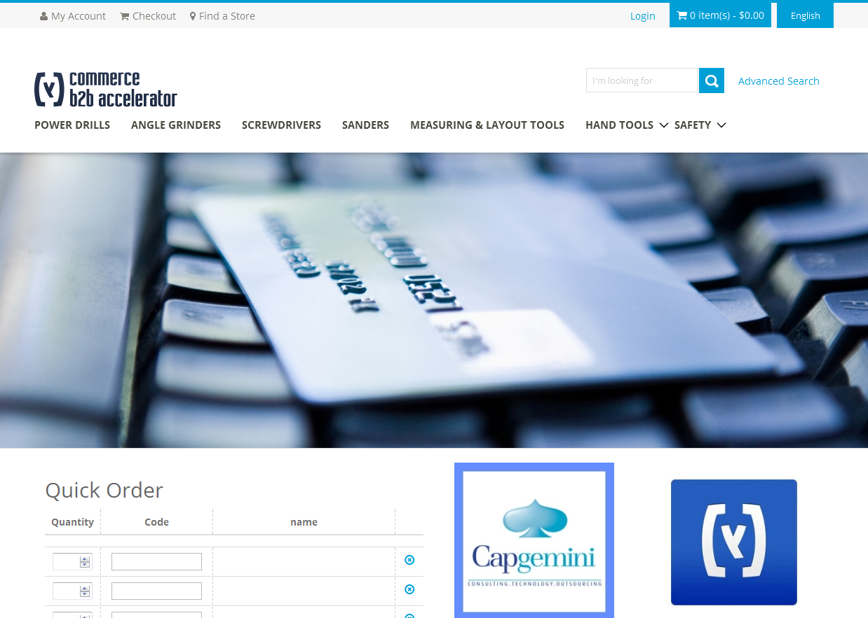

## Tablet range

The Powertools store within the tablet range hides or collapses some page elements.

For example, on the home page:

* The store header contains less information than desktop, such as category selections and other information such as cart total.
* The site background image is fully visible. However, its range is reduced and fills the screen, instead of being centered on the screen when viewed on a desktop.
* The images in the storefront display slightly smaller than on a desktop.

## Tablet screen capture

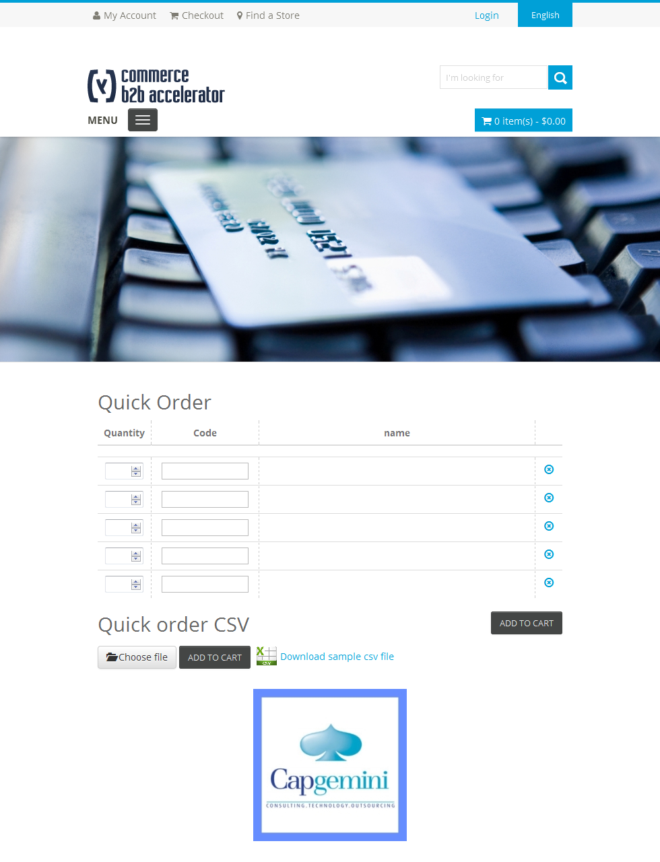

## Mobile range

The Powertools store within the mobile range hides or collapses most page elements.

For example, on the home page:

* The store header contains less information than desktop and tablet, such as category selection and other information.
* The site background image is fully visible. However, its range is reduced
* The images in the storefront display much smaller than on a desktop or tablet.

## Mobile screen capture

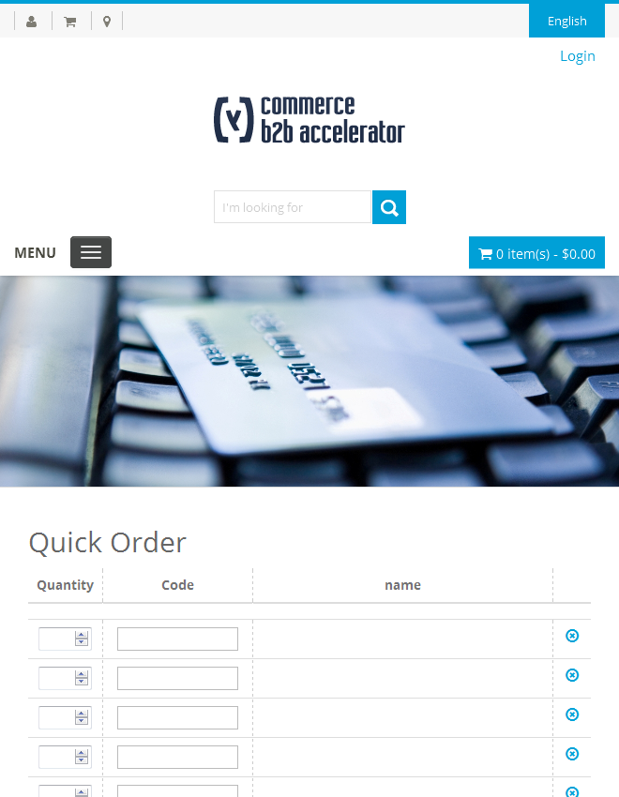

* + 1. Business Rule Description

## Page areas

The responsive storefront uses page space in the following ways:

**Header and footer**

The amount of information that the page header shows is based on the @media rule.

For example:

* The desktop header contains all information, such as available category selections and other information.
* The tablet header contains less information than the desktop, such as less available category selections and store information.
* The mobile header contains less information than the desktop and tablet, such as only one available department selection and store information.

The footer resizes to fit screen sizes with progressive enhancements for larger screen sizes.

**Sidebars**

Store content such as facets and category display widgets are collapsible in the sidebar, and initially collapse in the smaller view ranges to save space.

**Padding**

There is no visible padding to the left and right of store content on any devices or screen size. Therefore, store content is not collapsed into a smaller viewable range.

## Images

Images in the responsive storefront act dynamically according to device and screen sizes. For example:

**Background images**

The background images dynamically resize. For example:

* The desktop site background image is fully visible and centered.
* The tablet site background image is fully visible. However, its range is reduced and fills the screen, instead of being centered on the screen when viewed on a desktop.
* The mobile site background image is fully visible. However, its range is reduced and page elements such as e-Marketing spots and product listings hide its appearance.

**Site images**

The site images dynamically resize. For example:

* The desktop images in the storefront are large.
* The tablet images in the storefront are slightly smaller than on a desktop.
* The mobile images in the storefront are much smaller than on a desktop or tablet.
  1. Exception Management and Logging
     1. Exception Management

The Responsive Theme module does not require any code modifications and hence uses the out of the box exception management.

* + 1. Logging / Audit

The Responsive Theme module does not require any code modifications and hence uses the out of the box logging management.

* 1. Security requirements

The Responsive Theme module does not require any code modifications and hence uses the out of the box security management.